Digitizing notes for Operators

Satin Stitch Letters:

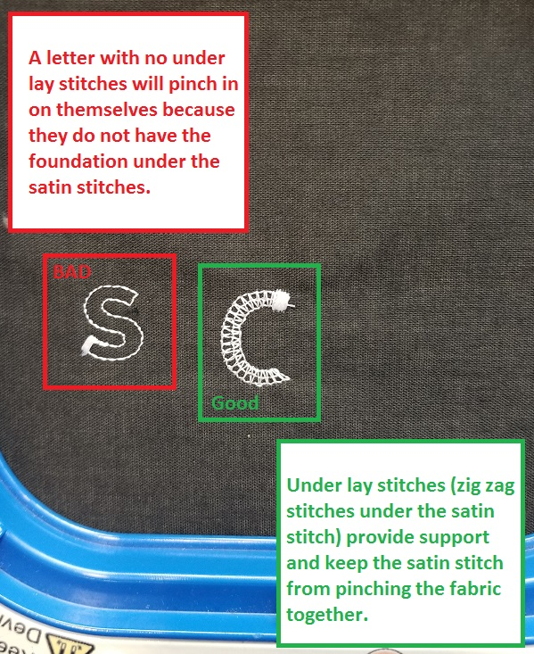

I’m hoping to give you the language you need to communicate issues with digitized files so we know how to ask for changes.

Tatami Stitches having good coverage

Often you want to blame the digitizing file for being not good enough but you are not using topping. Topping makes **ALL** designs look better as it raises the stitches up from the fabric. It **must** be used on fleece, knit, terry cloth, minky and fuzzy garments. It improved the quality of designs with small lettering and tiny details.

**Activity 1**: Embroidery Stitch outs on the provided fabrics swatches. The design will embroider "Without topping" and then has a built in stop. Add topping and then hit the run button on the machine and it will embroider "With topping". After you embroider all the swatches (Fleece, knit jacket, performance polo, tshirt), clean the embroidery and review the difference it makes.

**Activity 2**: Embroidery Design “Satin Stitch”

Notes on Satin Stitch

* This is the widest a satin stitch should be .25 inch wide. If you have a larger one, the embroidery stitches could be compromised.
* Its normal for the machine to slow down.
* There should be an underlay for support under it (Column 2). If the stitches seem to be pulling in on themselves, the underlay should be improved with more stitches.
* If the Satin stitch has poor density (Column), the fabric underneath will show through. This is an unacceptable quality of embroidery and we should send the file back and misprint garment.
* If the design unravels (Column 4), there is not an adequate lock down stitch programed into the file and the digitizer must adjust. (Operators in a pinch could use a fray lock - but that doesn’t fix the issue, only covers it up.)

Certain designs might be inappropriate for the hat they are destined for:

Hat design max guidelines:

Unstructured Hats 1.8" tall max (upsell bigger design to)

Structure Mid Profile Cap 2" max (upsell bigger design to)

Pro Style/5 panel Cap 2.25" Max

If the Client has more info than can fit in this space, recommended a second location on the back.

If a design it taller, the stitches will struggle near the top of the cap. You might see more broken needles, registration issues and ugly stitches. If you see designs that are taller than these recommendations, alert the manager before proceeding.

**Activity 3**: Have 3 cap designs on 3 different styles and ask the op if they are appropriate for each individual hat.